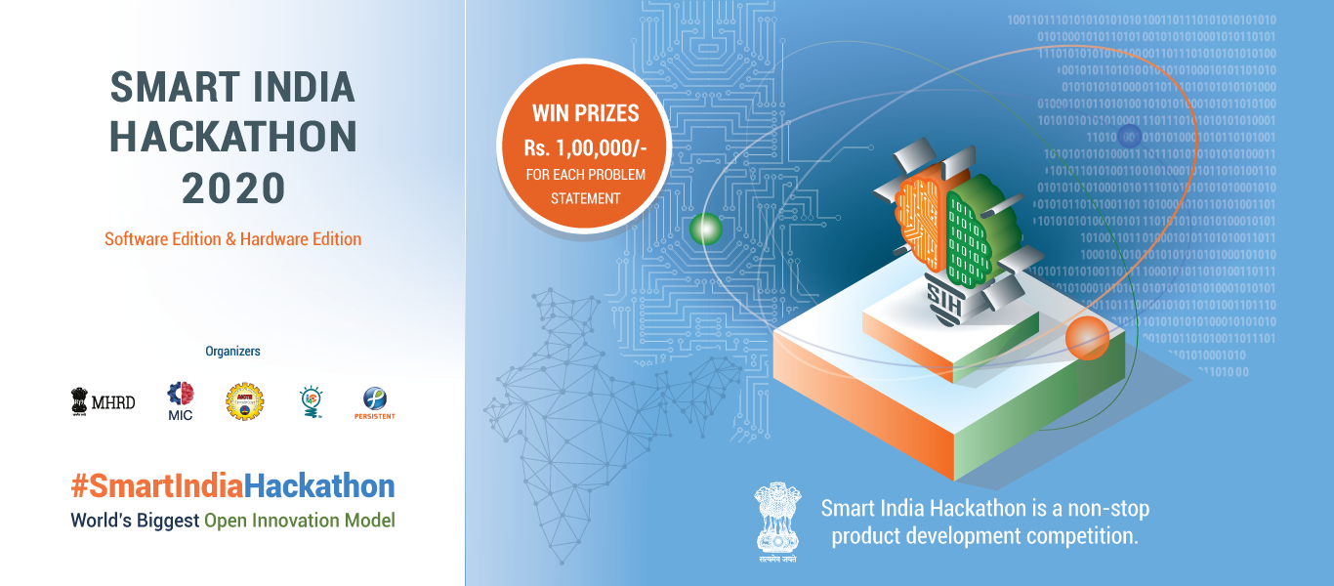

Ministry Category

Problem Statement

Team Name :

Organization/Ministry :

Category : Software/Hardware

Technology Bucket :

Problem Statement :

Team Leader Name

1 Prototype Sample
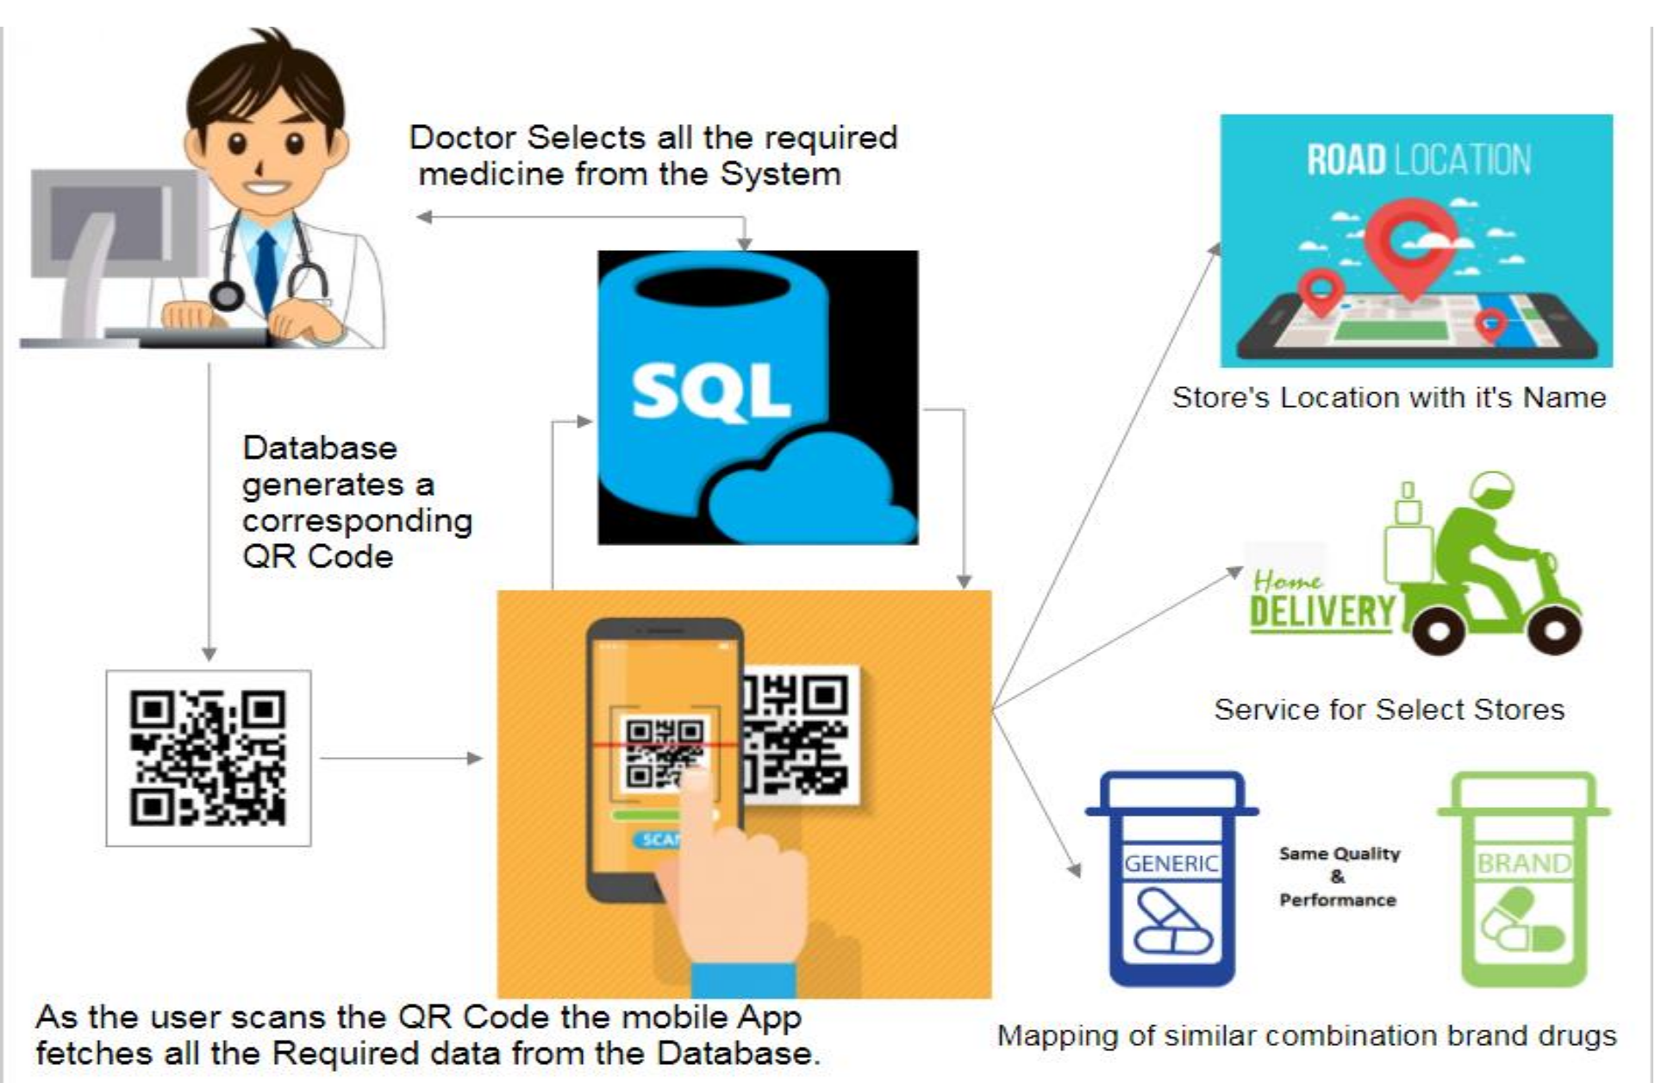

2

3

› A Database of all kinds of medicines, the stores where each drug is supplied and alternatives of each drug(if available of different brand) and list of medical stores providing home delivery service is maintained on our SQL Database.

Sample Technology Stack

Tech

ological

HTML5

•Frontend
CSS3

•Frontend
JavaScript

•Frontend
PHP

•Backend
MySQL

•Database
Adobe
PhoneGap

stack
•Mobile
Misc.

•JSON
•Google Maps API

Sample Use Case
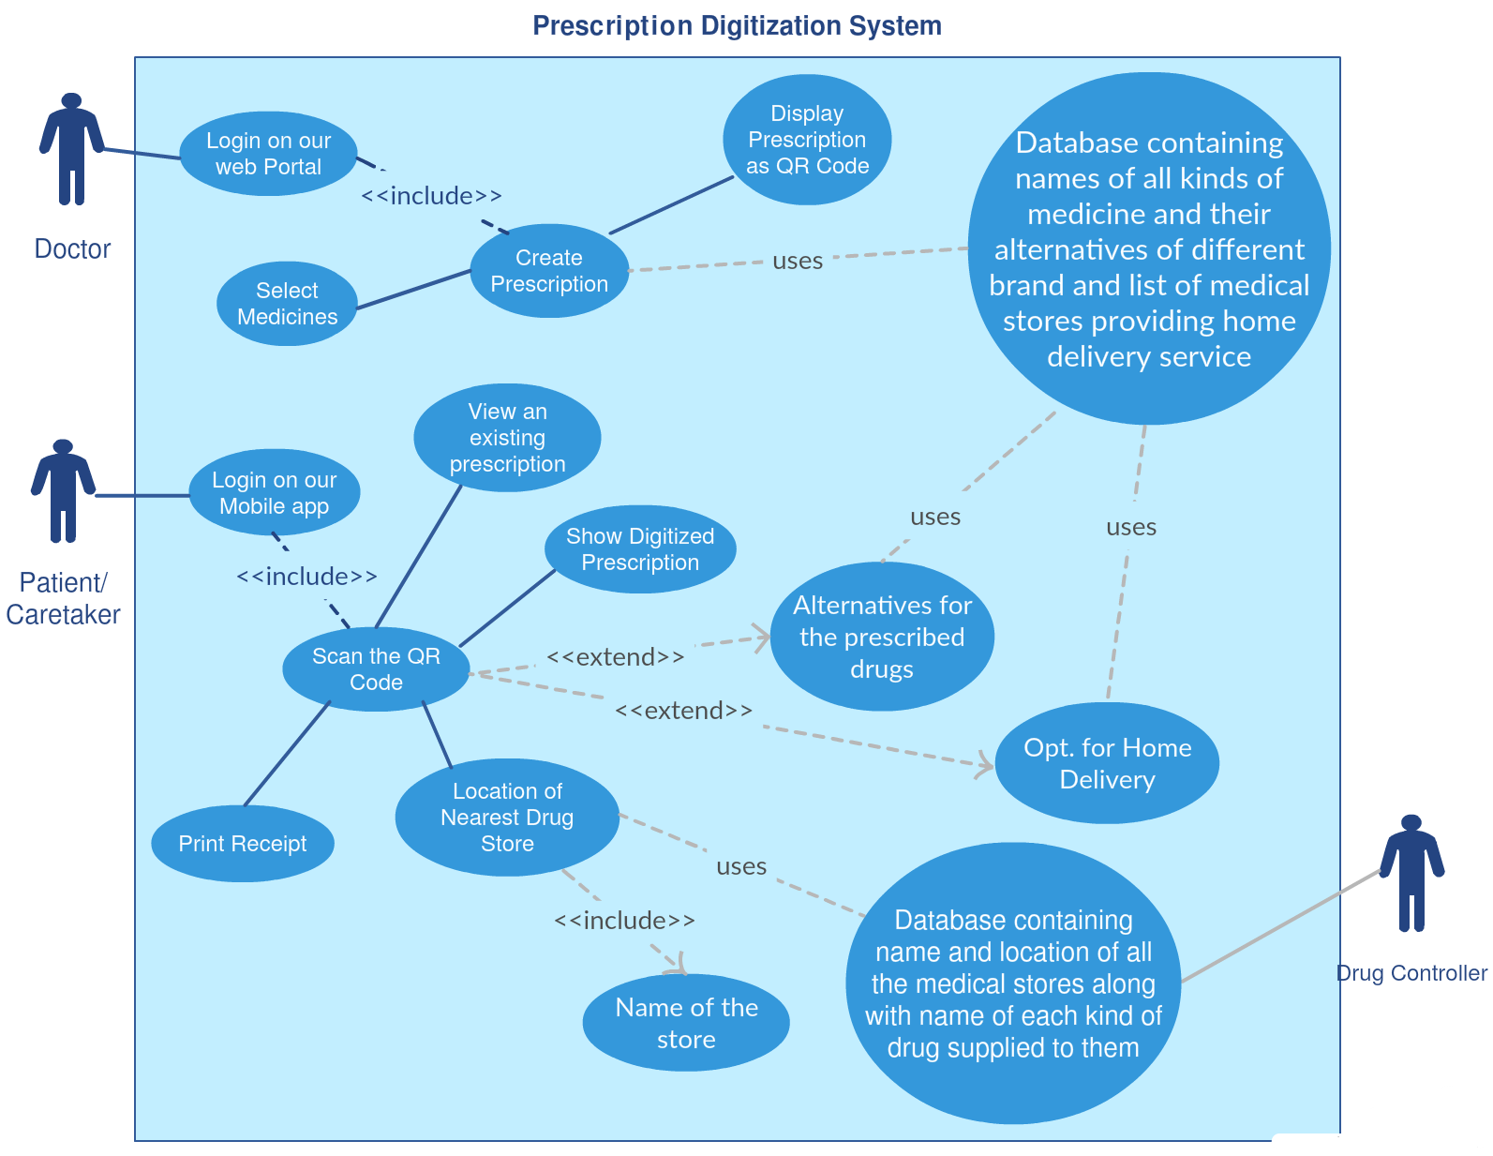

Dependencies / Show stopper

❑

Conclusion

